Entertainment Preferences
Project Objective:
The objective of this project is to analyse entertainment consumption patterns across different age groups and demographics to understand preferred entertainment types, platform usage trends, spending behaviour, and factors influencing satisfaction levels.
Data Collection Method: Data was collected through a structured survey targeting individuals aged 18–40. A total of 150 responses were compiled ensuring unbiased and neutral questions.
Data Cleaning Steps: No Data cleaning was Performed as the DATA obtained initially was cleaned.

- Which entertainment type is most preferred?
Preferred Entertainment Type | Count of Preferred_Entertainment_Type
Sports | 181
OTT | 167
Live Events | 167
Movies | 165
Gaming | 162
Music | 158
Grand Total | 1000

Overview on Entertainment Preferences:
Sports leads the preference list.
OTT platform & Live events content both perform equally well.
Entertainment preferences are evenly distributed, with Sports slightly leading, indicating a diversified market where personalized targeting will outperform category-focused strategies.

2) How many hours do people spend weekly on entertainment?
Mean | 17.314
Median | 17
Mode | 17
Min/ Lower Bound | 5
Max / Upper Bound | 30
Standard Deviation | 7.314055236
Variance | 53.495404
Q1 | 11
Q3 | 23
IQR | 12

People Spend an average of 17 Hours on entertainment on weekly basis.
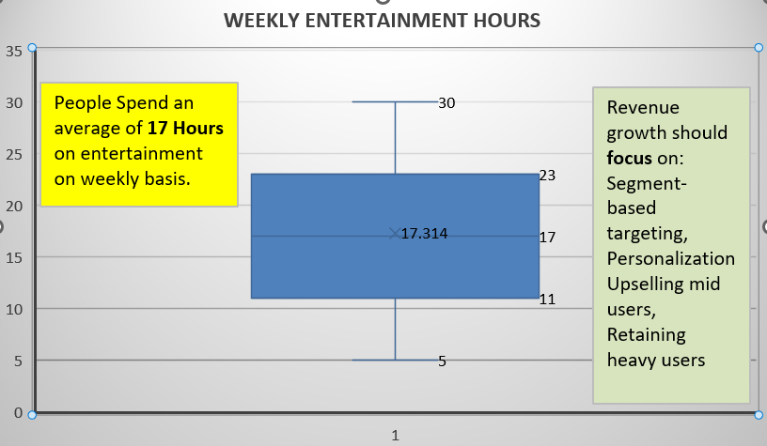

Overview on hours spent on weekly basis by people on Entertainment:
Found that the number of hours People spent on entertainment is 17 Hours on an average.
Because the mean is slightly higher than the median, the data shows a very slight positive skew (right skew) — considered as no skewness as it is extremely small.
No heavy concentration of extreme high-hour users.
User engagement distribution is balanced.

Central Tendency
- Mean, median, and mode are all ~17 hours.
- No Skewness.
- 50% of users fall between 11–23 hours weekly.
- Q1 = 11 hrs
- Q3 = 23 hrs
- IQR = 12 hrs
- No extreme outliers visible.
- The minimum time spent was observed as 5 hours and maximum time spent was 30 Hours.
Spread & Variability
Standard deviation of 7.31 suggests moderate variability.
Variance is: 53.495

- Does age influence the platform choice?

Age Group | Amazon Prime | Hotstar | Netflix | PlayStation | Spotify | Theatre | TV | YouTube | Grand Total
18-23 | 22 | 39 | 31 | 35 | 33 | 33 | 42 | 36 | 271
24-29 | 38 | 36 | 44 | 38 | 37 | 29 | 33 | 36 | 291
30-35 | 32 | 23 | 21 | 28 | 38 | 33 | 36 | 31 | 242
36-41 | 23 | 29 | 30 | 21 | 23 | 21 | 24 | 25 | 196
Grand Total | 115 | 127 | 126 | 122 | 131 | 116 | 135 | 128 | 1000

Overview on Platform Choice:
(Total Respondents = 1000)
The data represents media and entertainment platform preferences across four age groups (18–23, 24–29, 30–35, and 36–41).
Overall platform popularity (Grand Total):
- TV – 135 (Most preferred overall)
- Spotify – 131
- YouTube – 128
- Hotstar – 127
- Netflix – 126
- PlayStation – 122
- Theatre – 116
- Amazon Prime – 115 (Least preferred overall)
Traditional TV still leads slightly, but digital streaming and music platforms are very close behind, showing strong digital consumption trends.

Key Insights
- 24–29 is the most engaged age group across platforms.
- TV remains surprisingly strong across all age groups.
- Spotify dominates the 30–35 segment.
- Netflix is strongest among 24–29 and 36–41.
- Gaming (PlayStation) is most popular among 18–29, then drops significantly after 30.
- Traditional platforms (TV & Theatre) regain relative strength in 30+ groups.
Overall Trend
- Ages 18–29 → Digital-heavy consumption (OTT, Gaming, YouTube)
- Ages 30–35 → Balanced mix of digital + traditional
- Ages 36–41 → Moderate streaming, lower gaming engagement
- TV remains universally relevant

- What is the Average Monthly Spending on Entertainment?
Preferred Entertainment | Sum of Monthly_Spending_INR
Sports | 272559
Gaming | 261728
OTT | 254124
Live Events | 250838
Music | 250646
Movies | 248490
Grand Total | 1538385

Analysis on Central Tendency
Mean | 1538.385
Median | 1555
Mode | 644
Min | 7
Max | 3000
Range | 2993
Standard Deviation | 873.4983095
Variance | 762999.2968
Q1 | 788.5
Q3 | 2306.25
IQR | 1517.75
Upper Bound | 4582.875
Lower Bound | -1488.125

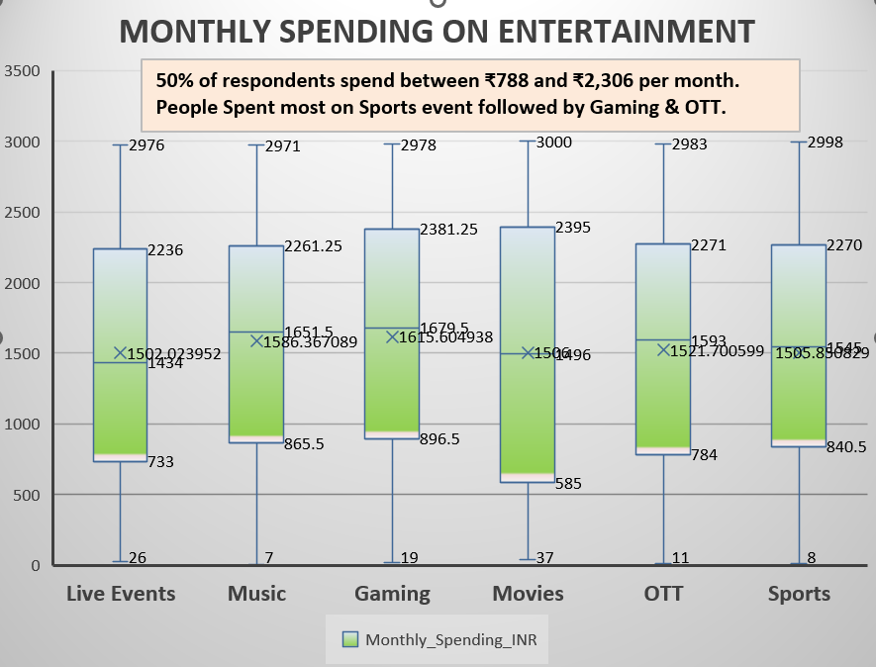

🔹 Overview on Monthly Spending
- Total Monthly Spending (All Respondents): ₹1,538,385
- The average monthly spending on entertainment is approximately ₹1,538 per person.
- Since the mean (₹1,538) and median (₹1,555) are very close, the spending distribution is fairly balanced with slight variation.
- No extreme outliers
- Balanced spending across entertainment types
- Since Mean < Median, the distribution shows slight negative skewness (left-skewed).
- However, the difference between mean and median is small (₹17), indicating the skew is very mild.
- The much lower mode (₹644) suggests a concentration of lower spenders, but the overall distribution remains close to symmetrical.
The data is approximately normally distributed with very slight negative skewness.
There is no strong evidence of extreme skew.

5.) Does subscription status impact satisfaction level?
Satisfaction Level / Rating | Free | Paid | Grand Total
1 | 89 | 100 | 189
2 | 94 | 105 | 199
3 | 106 | 91 | 197
4 | 99 | 105 | 204
5 | 114 | 97 | 211
Grand Total | 502 | 498 | 1000

Overview on Satisfaction level:
- Total Respondents: 1000
- Free Users: 502 (50.2%)
- Paid Users: 498 (49.8%)
The sample is almost perfectly balanced between Free and Paid users, which makes comparison reliable.
📈 Satisfaction Distribution Comparison
🔹 Rating 1 (Lowest Satisfaction)
- Free: 89
- Paid: 100
- Paid users slightly higher dissatisfaction.
🔹 Rating 2
- Free: 94
- Paid: 105
- Again, Paid users slightly more in low satisfaction.
🔹 Rating 3 (Neutral)
- Free: 106
- Paid: 91
- Free users more neutral responses.
🔹 Rating 4
- Free: 99
- Paid: 105
- Slightly more Paid users satisfied.
🔹 Rating 5 (Highest Satisfaction)
- Free: 114
- Paid: 97
- Free users show higher top satisfaction.
Key Insight:
Free users appear marginally more satisfied overall.
Paid users may have higher expectations, leading to slightly more dissatisfaction.
Subscription status does not strongly impact satisfaction level.
There is no major difference in satisfaction levels between Free and Paid users.
While Free users show a slightly higher average satisfaction score, the variation is minimal.
Paid users may require better value perception or premium experience enhancements.
Improving premium differentiation could raise paid-user satisfaction.

6.) Is there corelation between weekly hours and spending?
Hours Spent on Weekly basis | Sum of Monthly_Spending_INR
5 | 45676
6 | 67805
7 | 49296
8 | 60167
9 | 72258
10 | 52154
11 | 58858
12 | 60165
13 | 44288
14 | 46521
15 | 67557
16 | 41247
17 | 84287
18 | 72006
19 | 58050
20 | 56554
21 | 60706
22 | 66057
23 | 71385
24 | 54931
25 | 64785
26 | 70129
27 | 59873
28 | 52871
29 | 47653
30 | 53106
Grand Total | 1538385

Overview on comparison between Weekly hours spent on entertainment & Expenditure:
Total Respondents: 1000
Total Weekly Hours: 17,314
Total Monthly Spending: ₹1,538,385
Average Weekly Entertainment Hours: 17.3 hours per week
Average Monthly Spending: ₹1,538 per month
- Higher weekly hours (20–30 hrs) frequently show higher spending values.
- Very low-hour users (5–8 hrs) often show lower or inconsistent spending.
- However, there are exceptions (some low-hour users spend high and vice versa).
Correlation:
Correlation Coefficient
Correl | 0.073973495
There appears to be a moderate positive relationship between weekly hours and spending:
➡ As engagement (hours) increases, spending generally tends to increase.
➡ But the relationship is not perfectly linear due to variability.
Key insight:
- Average user: 17 hrs/week + ₹1,538/month
- Relationship between hours and spending: Moderate positive association
- Market structure: Tiered (Light–Mid–Heavy users)
- Strong opportunity to align pricing strategy with engagement level.
7. How does the intersection of geographic location and gender influence monthly spending across different entertainment genres?
Gender | Genre |  |  |  |  |  |  |  | Grand Total
Gender | Action | Comedy | Drama | Horror | Pop | Romance | Sports | Thriller | Grand Total
Female | 65378 | 66179 | 87860 | 82041 | 48552 | 58173 | 70019 | 57595 | 535797
Male | 55789 | 70833 | 53570 | 56512 | 53082 | 68590 | 77491 | 68777 | 504644
Other | 54873 | 65883 | 74686 | 50616 | 50007 | 67092 | 68871 | 65916 | 497944
Grand Total | 176040 | 202895 | 216116 | 189169 | 151641 | 193855 | 216381 | 192288 | 1538385
Metro :
Gender | Metro
Gender | Action | Comedy | Drama | Horror | Pop | Romance | Sports | Thriller | Grand Total
Female | 21050 | 28736 | 32656 | 34743 | 14096 | 17469 | 21999 | 25882 | 196631
Male | 15157 | 17617 | 12573 | 24982 | 15559 | 23778 | 21706 | 17789 | 149161
Other | 15653 | 29454 | 22226 | 11659 | 17644 | 26038 | 21071 | 16576 | 160321
Grand Total | 51860 | 75807 | 67455 | 71384 | 47299 | 67285 | 64776 | 60247 | 506113

Rural:
Gender | Rural
Gender | Action | Comedy | Drama | Horror | Pop | Romance | Sports | Thriller | Grand Total
Female | 20340 | 20445 | 27884 | 22594 | 15646 | 17116 | 26791 | 12494 | 163310
Male | 21367 | 27787 | 22964 | 10219 | 13854 | 25034 | 27189 | 29668 | 178082
Other | 19555 | 15846 | 29408 | 16333 | 19363 | 13950 | 21066 | 21412 | 156933
Grand Total | 61262 | 64078 | 80256 | 49146 | 48863 | 56100 | 75046 | 63574 | 498325

Urban:
Gender | Urban
Gender | Action | Comedy | Drama | Horror | Pop | Romance | Sports | Thriller | Grand Total
Female | 23988 | 16998 | 27320 | 24704 | 18810 | 23588 | 21229 | 19219 | 175856
Male | 19265 | 25429 | 18033 | 21311 | 23669 | 19778 | 28596 | 21320 | 177401
Other | 19665 | 20583 | 23052 | 22624 | 13000 | 27104 | 26734 | 27928 | 180690
Grand Total | 62918 | 63010 | 68405 | 68639 | 55479 | 70470 | 76559 | 68467 | 533947

Overview on region and gender based monthly spend on entertainment:
- Across all demographics and regions, the total monthly spending on entertainment is ₹1,538,385.
- Sports is the highest-grossing genre overall, with a total spend of ₹216,381, closely followed by Drama at ₹216,116.
- The Urban sector is the largest contributor to revenue, accounting for ₹533,947 Metro users prioritize Comedy, spending ₹75,807, which is significantly higher than their spend on Pop or Action.
- Drama dominates the Rural market, with the highest individual segment spend of ₹80,256.
- Females lead the spending categories with a total of ₹535,797, followed by Males at ₹504,644.
- Males spend the most on Sports (₹77,491) and Comedy (₹70,833).
- This group shows a very balanced spending profile, with Drama (₹74,686) and Sports (₹68,871) leading their preferences.
8. What is the distribution of educational level among respondents?

Overview on the respondent’ educational level:

- The survey respondents are almost evenly distributed across education levels, with School-level individuals making up 35.40% (354).
- Post-Graduates (PG) at 33.50% (335).
- Undergraduates (UG) at 31.10% (311) of the 1,000-person sample.

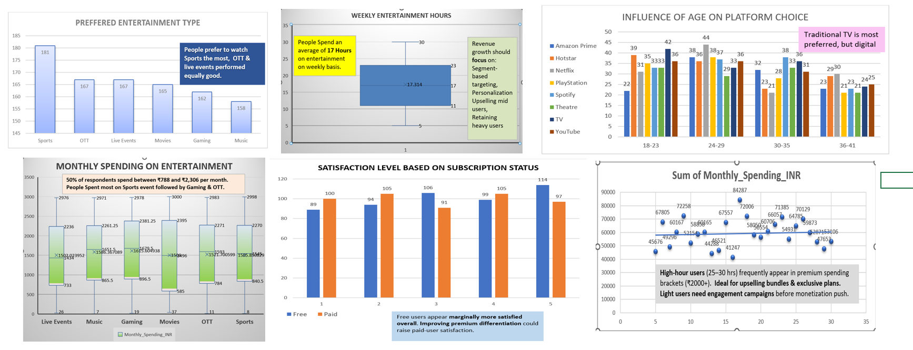

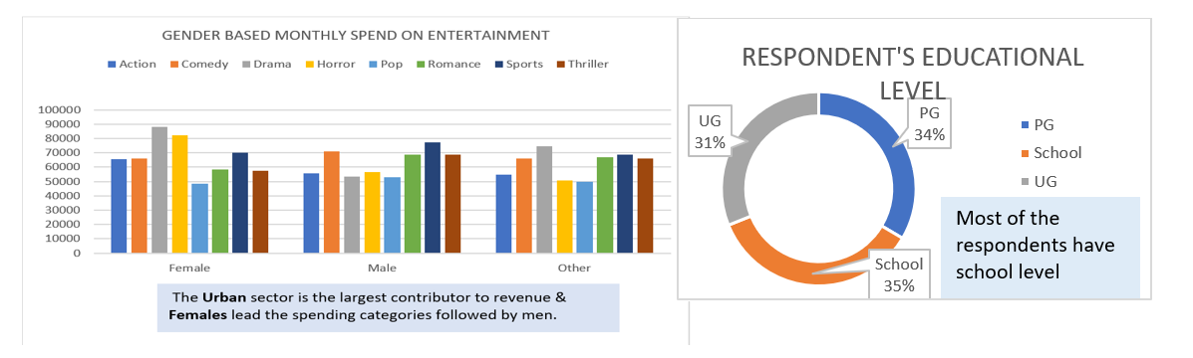

FINAL OVERVIEW FROM THE ANALYSES:

" Entertainment Preferences & Consumption Patterns," analyses the consumption patterns of 1,000 respondents aged 18–40. Below is a high-level overview of the findings:

- Engagement & Platform Trends

- Weekly Usage: On average, people spend 17.3 hours per week on entertainment. Engagement is balanced, with 50% of users falling between 11 and 23 hours.

- Top Platforms: TV (135 preferences) remains the most popular platform, followed closely by Spotify (131) and YouTube (128).

- Age Dynamics: Younger audiences (18–29) lean toward digital consumption like OTT and gaming, while traditional platforms like TV and Theatre regain strength in the 30+ age groups.

- Spending Patterns

- Average Spend: The average monthly expenditure is approximately ₹1,538 per person. Total spending across the sample reaches ₹1,538,385.

- Top Genres: Sports (₹216,381) and Drama (₹216,116) are the highest-grossing genres. Pop content consistently sees the lowest spend across all demographics.

- Regional & Gender Drivers: Urban areas are the largest revenue contributors (₹533,947). Females lead overall spending, particularly in Drama and Horror, while Males spend most on Sports and Comedy.

- Satisfaction & Subscription

- Subscription Impact: The user base is almost perfectly split between Free (50.2%) and Paid (49.8%) users.
- Perceived Value: Paid status does not strongly impact satisfaction; in fact, free users appear marginally more satisfied, likely due to having lower expectations than paid subscribers.

- Respondent Profile

- Education: Respondents are evenly distributed among those with School-level education (35.4%), Post-Graduates (33.5%), and Undergraduates (31.1%).

